Defining Time Blocks for Trucks

- Bring up the GIS Maintenance Tool.

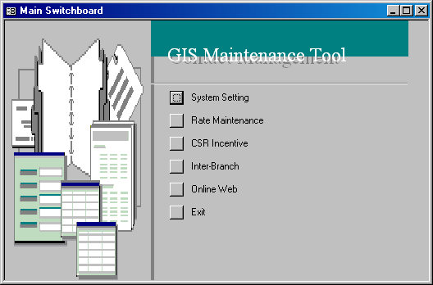

- Select Online Web.

- Select Truck Time Block.

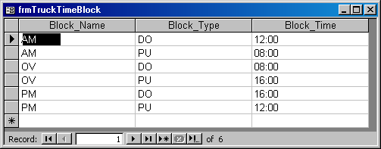

- Change the Block_Time.

Each time block has to be defined by a pick up and drop off time. Therefore you will see 2 block types for each block name.

Let’s take a look at this line - Block_Name=AM; Block_Type=PU; Block_Time=08:00
This means that the pick up time for the AM block is at 8AM.

From this table, we know that any rental between 8AM to 12PM fall within the AM block, any rental from 12PM to 4PM is within the PM block and anything after the PM and before the AM block will be within the OV block.

Entering Location Vehicle Rates

- Bring up the GIS Maintenance Tool.

- Select Online Web.

- Select Online Truck Reservation Rate next to open the Truck Reservation Rate table.

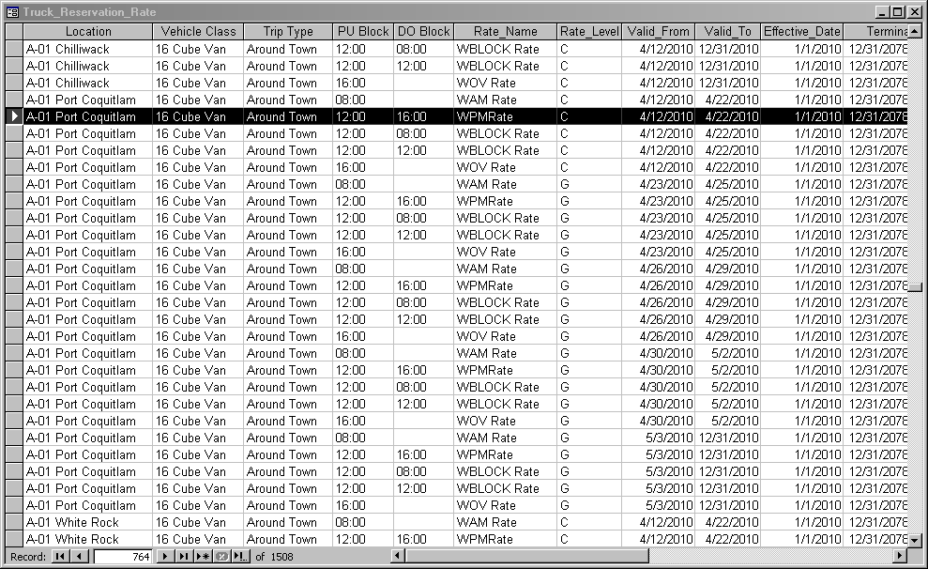

- Move down the table until you reach the end. You will know it’s the end when you see an empty row with an asterisk at the left-most cell.

- Copy the rates from your Excel rate sheet, go back to the Truck Reservation Rate table and right-click on the cell to paste all the copied rows.

NOTE
You can only enter ‘Around Town’ rates in the GIS Maintenance Tool. Any ‘Round Trip’ rates entered here WILL NOT be reflected in GIS.

